https://shorturl.at/kAHNV

**\*\*\*\*\*\*\*\*\*\*\*\*\*\*\*\*\*\*\*\*\*\*\*\*\*\*\*\*\*\*\*\*\*\*\*\*\*\*\*\*\*\*\*\*\*\*\*\*\*\*\*\*\*\*\*\*\*\*\*\*\*\*\*\*\*\*\*\*\*\*\*\*\*\*\*\*\*\*\*\*\*\***

**Dropdowns**

**GridSystem**

**Forms**

**Badge**

**Breadcrumb**

**Spinners**

**\*\*\*\*\*\*\*\*\*\*\*\*\*\*\*\*\*\*\*\*\*\*\*\*\*\*\*\*\*\*\*\*\*\*\*\*\*\*\*\*\*\*\*\*\*\*\*\*\*\*\*\*\*\*\*\*\*\*\*\*\*\*\*\*\*\*\*\*\*\*\*\*\*\*\*\*\*\*\*\*\*\***

================================================================

dropdown

================================================================

dropdown-toggle

dropdown-menu

dropdown-item

dropdown-toggle-split

dropdown-divider

data-toggle = "dropdown"

<body>

<div class="container mt-5">

<div class="input-group">

<div class="input-group-prepend">

<button class="btn btn-secondary">Initials</button>

<button class="btn btn-secondary

dropdown-toggle-split

dropdown-toggle"

data-toggle = "dropdown"></button>

<div class="dropdown-menu">

<div class="dropdown-item">Master</div>

<div class="dropdown-item">Miss</div>

<div class="dropdown-item">Mr</div>

<div class="dropdown-item">Mrs</div>

<div class="dropdown-divider"></div>

<div class="dropdown-item">Dr</div>

</div>

</div>

<input type="text" class="form-control">

</div>

</div>

</body>

================================================================

Grid System

================================================================

- Bootstrap divides screen into 12 equal columns

Screen sizes(width in px)

es sm md lg xl xxl(B5.0 onw)

<576 >=576 >=768 >=992 >=1200 >=1400

<body>

<div class=" mt-5">

<div class="row">

<div class="col bk">Col1</div>

<div class="col bk">Col2</div>

</div>

<div class="row">

<div class="col bk">Col1</div>

<div class="col bk">Col2</div>

<div class="col bk">Col3</div>

</div>

<div class="row">

<div class="col bk">Col1</div>

<div class="col bk">Col2</div>

<div class="col bk">Col3</div>

<div class="col bk">Col4</div>

</div>

<div class="row">

<div class="col bk">Col1</div>

<div class="col bk">Col2</div>

<div class="col bk">Col3</div>

<div class="col bk">Col4</div>

<div class="col bk">Col5</div>

<div class="col bk">Col6</div>

</div>

<div class="row">

<div class="col bk">Col1</div>

<div class="col bk">Col2</div>

<div class="col bk">Col3</div>

<div class="col bk">Col4</div>

<div class="col bk">Col5</div>

<div class="col bk">Col6</div>

<div class="col bk">Col7</div>

<div class="col bk">Col8</div>

<div class="col bk">Col9</div>

<div class="col bk">Col10</div>

<div class="col bk">Col11</div>

<div class="col bk">Col12</div>

</div>

<hr>

<div class="row">

<div class="col bk">Col1</div>

<div class="col bk">Col2</div>

<div class="col bk">Col3</div>

<div class="col bk">Col4</div>

<div class="col bk">Col5</div>

</div>

<div class="row">

<div class="col bk">Col1</div>

<div class="col bk">Col2</div>

<div class="col bk">Col3</div>

<div class="col bk">Col4</div>

<div class="col bk">Col5</div>

<div class="col bk">Col6</div>

<div class="col bk">Col7</div>

</div>

<div class="row">

<div class="col bk">Col1</div>

<div class="col bk">Col2</div>

<div class="col bk">Col3</div>

<div class="col bk">Col4</div>

<div class="col bk">Col5</div>

<div class="col bk">Col6</div>

<div class="col bk">Col7</div>

<div class="col bk">Col8</div>

<div class="col bk">Col9</div>

<div class="col bk">Col10</div>

<div class="col bk">Col11</div>

<div class="col bk">Col12</div>

<div class="col bk">Col13</div>

<div class="col bk">Col14</div>

</div>

<hr>

<div class="row">

<div class="col-4 bk">Col1</div>

<div class="col bk">Col2</div>

</div>

<div class="row">

<div class="col-4 bk">Col1</div>

<div class="col bk">Col2</div>

<div class="col-3 bk">Col3</div>

</div>

<div class="row">

<div class="col-4 bk">Col1</div>

<div class="col-4 bk">Col2</div>

</div>

<div class="row">

<div class="col-4 bk">Col1</div>

<div class="col"></div>

<div class="col-4 bk">Col2</div>

</div>

Nested Grid

<div class="row">

<div class="col bk"> _ </div>

<div class="col bk">

<div class="row">

<div class="col bk"> _ </div>

<div class="col bk"> _ </div>

<div class="col bk"> _ </div>

</div>

<div class="row">

<div class="col bk"> _ </div>

<div class="col bk"> _ </div>

<div class="col bk"> _ </div>

</div>

<div class="row">

<div class="col bk"> _ </div>

<div class="col bk"> _ </div>

<div class="col bk"> _ </div>

</div>

</div>

<div class="col bk"> _ </div>

</div>

<div class="row">

<div class="bk col-sm-4">Col1</div>

<div class="bk col-sm-4">Col2</div>

<div class="bk col-sm-4">Col3</div>

</div>

<div class="row">

<div class="bk col-md-4">Col1</div>

<div class="bk col-md-4">Col2</div>

<div class="bk col-md-4">Col3</div>

</div>

<div class="row">

<div class="bk col-lg-4">Col1</div>

<div class="bk col-lg-4">Col2</div>

<div class="bk col-lg-4">Col3</div>

</div>

<!--Generally used in card layout-->

<div class="row row-cols-4">

<div class="col bk">Col1</div>

<div class="col bk">Col2</div>

<div class="col bk">Col3</div>

<div class="col bk">Col4</div>

<div class="col bk">Col5</div>

<div class="col bk">Col6</div>

</div>

</div>

</body>

================================================================

Forms

================================================================

form-group

form-control

form-text

form-check

form-check-inline

form-check-label

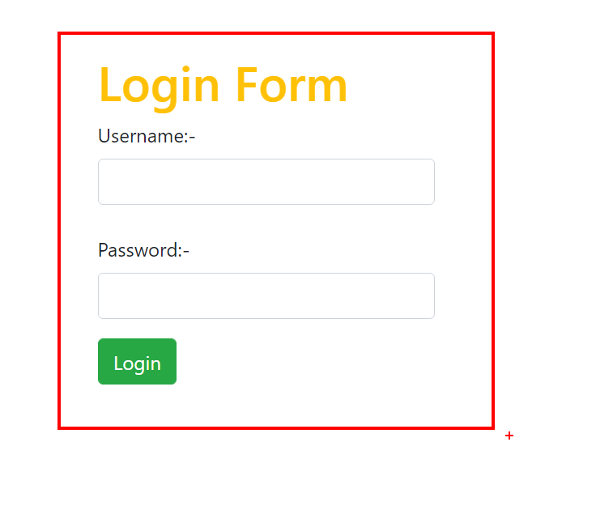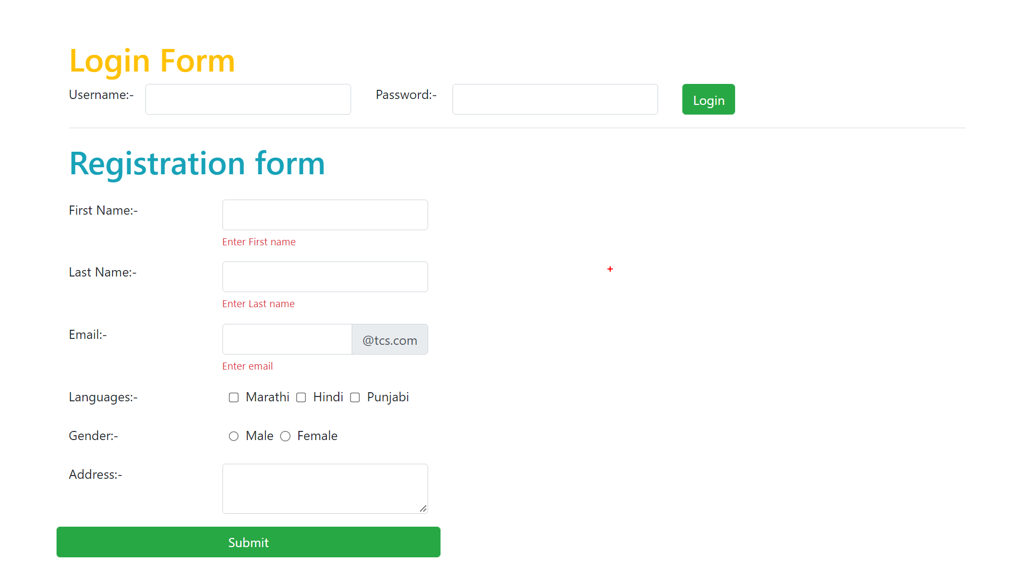

<body>

<div class="container mt-5">

<div class="h1 text-warning">Login Form</div>

<form class="row">

<!--Username-->

<label class="col-1">Username:- </label>

<div class="col-3">

<input type="text" class="form-control">

</div>

<!--Password-->

<label class="col-1">Password:- </label>

<div class="col-3">

<input type="password" class="form-control ">

</div>

<!--Login Button-->

<div class="col">

<input type="submit" value="Login" class="btn btn-success">

</div>

</form>

<hr>

<div class="h1 text-warning">Login Form</div>

<form class="w-25">

<!--Username-->

<label>Username:- </label>

<div>

<input type="text" class="form-control">

</div>

<!--Password-->

<label>Password:- </label>

<div>

<input type="password" class="form-control ">

</div>

<!--Login Button-->

<div class=" my-2">

<input type="submit" value="Login" class="btn btn-success">

</div>

</form>

<hr>

<div class="h1 text-info">Registration form</div>

<form>

<!--First Name-->

<div class="form-group row">

<div class="col-2">

<label>First Name</label>

</div>

<div class="col-3">

<input type="text" class="form-control">

<small class="form-text text-danger">Enter First Name</small>

</div>

</div>

<!--Last name-->

<div class="form-group row">

<div class="col-2">

<label>Last Name:- </label>

</div>

<div class="col-3">

<input type="text" class="form-control">

<small class="form-text text-danger">Enter Last name</small>

</div>

</div>

<!--email-->

<div class="form-group row">

<div class="col-2">

<label>Email:- </label>

</div>

<div class="col-3 ">

<div class="input-group">

<input type="email" class="form-control">

<div class="input-group-append">

<span class="input-group-text">

@tcs.com

</span>

</div>

</div>

<small class="form-text text-danger">Enter email</small>

</div>

</div>

<!--Languages-->

<div class="form-group row">

<div class="col-2">

<label>Languages:- </label>

</div>

<div class="col-3">

<div class="form-check-inline">

<input type="checkbox" class="form-check-input ">

<label class="form-check-label mr-2">Marathi</label>

<input type="checkbox" class="form-check-input ">

<label class="form-check-label mr-2">Telugu</label>

<input type="checkbox" class="form-check-input ">

<label class="form-check-label mr-2">Hindi</label>

</div>

<small class="form-text text-danger">Select atleast one language</small>

</div>

</div>

<!--Gender-->

<div class="form-group row">

<div class="col-2">

<label>Gender:- </label>

</div>

<div class="col-3">

<div class="form-check-inline">

<input type="radio" class="form-check-input " name = 'g'>

<label class="form-check-label mr-2">Male</label>

<input type="radio" class="form-check-input " name = 'g'>

<label class="form-check-label mr-2">Female</label>

</div>

<small class="form-text text-danger">Select gender</small>

</div>

</div>

<!--Address-->

<div class="form-group row">

<div class="col-2">

<label>Address:- </label>

</div>

<div class="col-3">

<textarea class="form-control"></textarea>

<small class="form-text text-danger">Enter address</small>

</div>

</div>

<!--Submit-->

<div class="form-group row">

<input type="submit" class="btn btn-success col-5">

</div>

</form>

</div>

</body>

================================================================

Badge:-

================================================================

- badge

- badge-pill

- badge-*...*

<style>

.blink {

animation: blinking 0.25s infinite;

}

@keyframes blinking {

25% {

color: blue;

background-color: yellow;

}

75%{

color: white;

background-color: white;

}

}

</style>

<body>

<div class="container mt-5">

<div class="list-group w-25">

<div class="list-group-item ">Angular

<div class="badge badge-info">Framework</div>

</div>

<div class="list-group-item">ReactJS

<div class="badge badge-primary">Lib</div>

</div>

<div class="list-group-item">Node.js

<div class="badge badge-pill badge-secondary">Server</div>

</div>

<div class="list-group-item">Nextjs

<div class="badge blink">new</div>

</div>

</div>

</div>

</body>

================================================================

breadcrumb

================================================================

"/" character or separator

breadcrumb

breadcrumb-item

active

<style>

.breadcrumb-item+.breadcrumb-item::before {

float: left;

padding-right: 0.5rem;

content: "-";

color: black;

}

.breadcrumb-item+.breadcrumb-item:hover::before {

content: "/";

}

</style>

<div class="container mt-5">

<nav>

<ul class="breadcrumb">

<li class="breadcrumb-item active">Home</li>

<li class="breadcrumb-item">About</li>

<li class="breadcrumb-item">Portfolio</li>

<li class="breadcrumb-item">Contact</li>

<li class="breadcrumb-item">Logout</li>

</ul>

</nav>

</div>

================================================================

Spinners:-

================================================================

- spinner-border

- spinner-grow

- spinner-border-sm

- spinner-grow-sm

<style>

.spinner-border {

display: inline-block;

width: 2rem;

height: 2rem;

vertical-align: -0.125em;

border: 0.25em solid currentcolor;

border-right-color: transparent;

border-radius: 25%;

-webkit-animation: .75s linear infinite spinner-border;

animation: .5s linear infinite spinner-border;

}

</style>

<body style="background: linear-gradient(to top, red,pink)">

<div class="container mt-5">

<div class="spinner-border spinner-border-sm text-primary"></div>

<div class="spinner-border text-primary"></div>

<div class="spinner-border text-secondary"></div>

<div class="spinner-border text-success"></div>

<div class="spinner-border text-warning"></div>

<div class="spinner-border text-danger"></div>

<div class="spinner-border text-info"></div>

<div class="spinner-border text-dark"></div>

<div class="spinner-border text-light"></div>

<div class="spinner-border text-white"></div>

<div class="spinner-border text-black"></div>

<div class="spinner-border text-white-50"></div>

<div class="spinner-border text-black-50"></div>

<hr>

<div class="spinner-grow spinner-grow-sm text-primary"></div>

<div class="spinner-grow text-primary"></div>

<div class="spinner-grow text-secondary"></div>

<div class="spinner-grow text-success"></div>

<div class="spinner-grow text-warning"></div>

<div class="spinner-grow text-danger"></div>

<div class="spinner-grow text-info"></div>

<div class="spinner-grow text-dark"></div>

<div class="spinner-grow text-light"></div>

<div class="spinner-grow text-white"></div>

<div class="spinner-grow text-black"></div>

<div class="spinner-grow text-white-50"></div>

<div class="spinner-grow text-black-50"></div>

</div>

</body>

================================================================

================================================================